ART WORKS LIST
CHARLOTTE ESPOSITO
ARTIST

All art works are original and produced by Brighton (UK) Artist Charlotte Esposito. All pieces come with a Certificate of Authenticity which is a legal document that you should keep as the new owner of the artwork and pass on as part of any future resale.

Please keep in mind that copyright remains with the artist & that Artists Resale Rights apply in terms of any future sale.

All work can be gift wrapped if required.
Interior Art Projects:
Charlotte is also available for commissions & interior wall murals and can work to brief if required; including matching artworks with your colour scheme. She has previously worked on both residential and commercial interior painting projects - in high end houses, bars, restaurants, offices and hotels and is able to provide site specific works that co-ordinate with your design project.
Bespoke Fashion: if you require a bespoke fashion item e.g. painted shoes, jeans, tops or jackets please discuss your requirements with the artist.

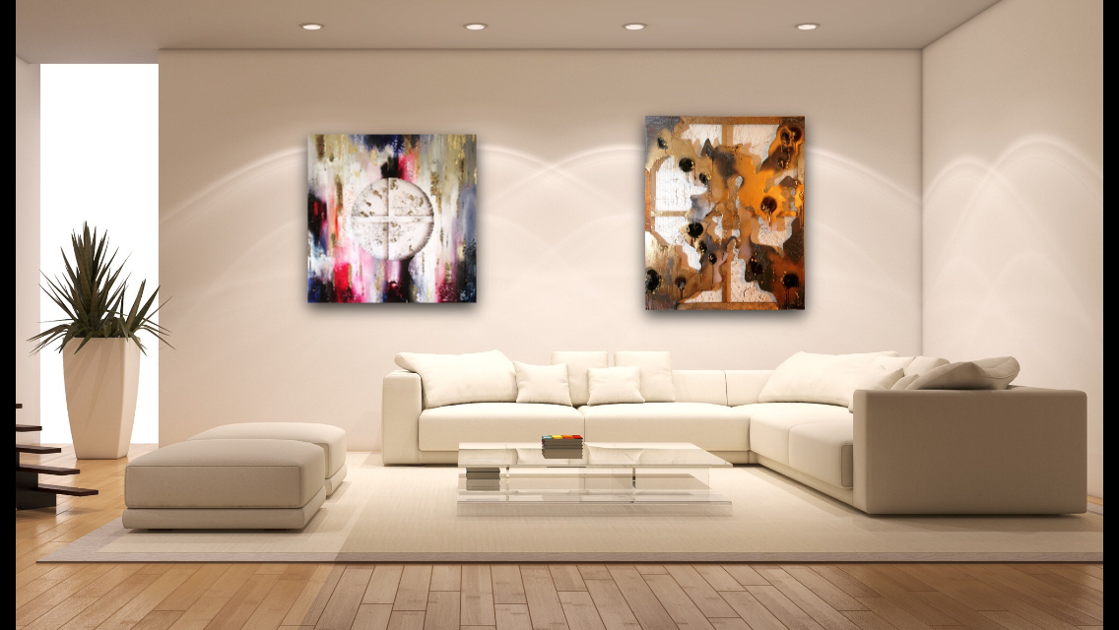

Painting 1: Emerald Dreams, 2020
61 x 76 x 3.5 cm

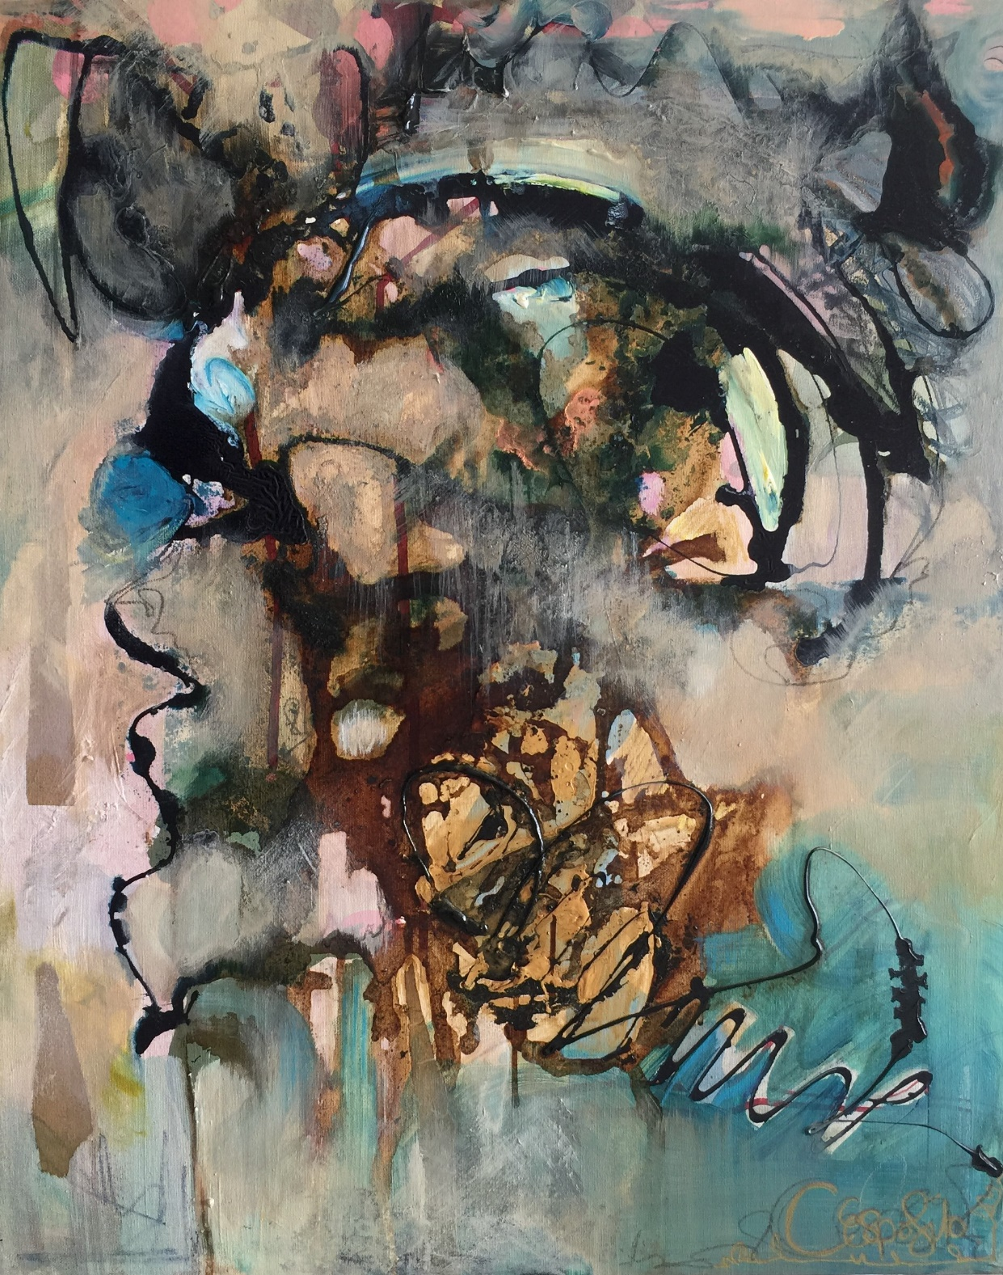

PRICE: £700 + shipping (if required)
Mixed Media on Canvas: Acrylic, Indian ink, Coffee, Vitral, Graphite, Collage, Whisky, Emulsion and Oil

Painting 2: Amethyst Haze, 2020
40 x 120 x 4cm

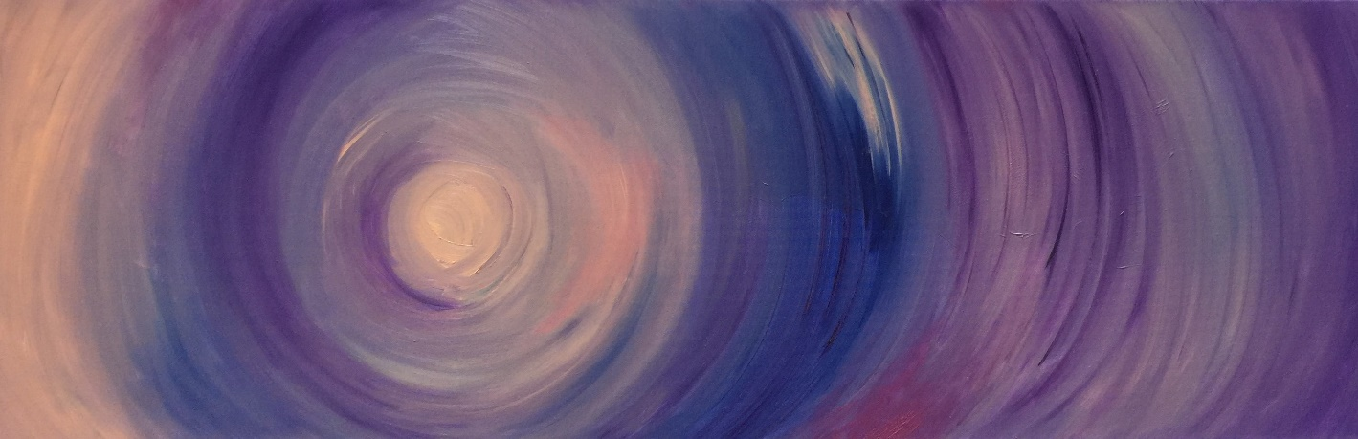

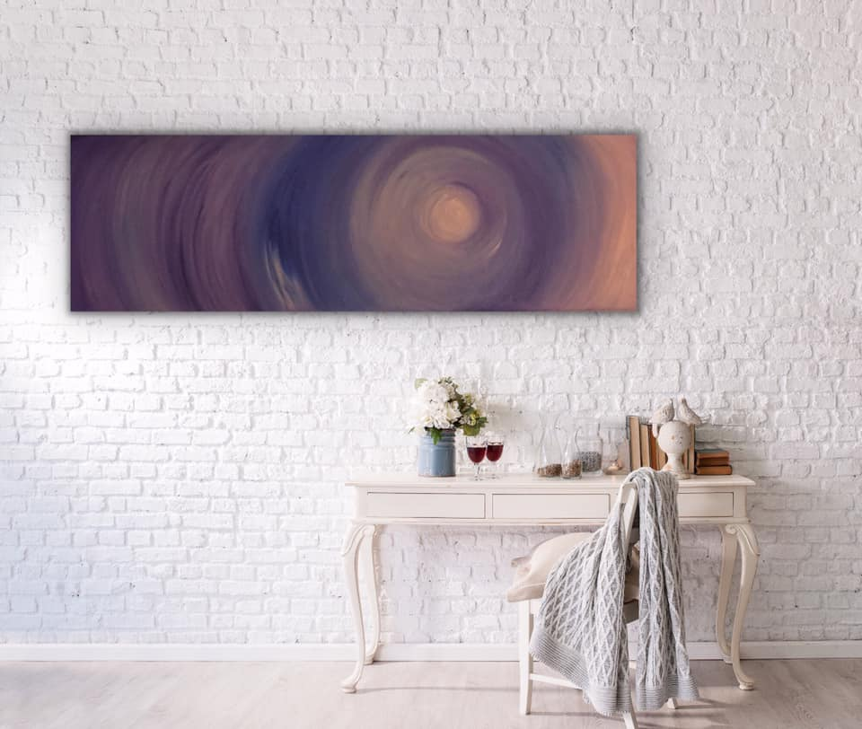

PRICE: £500 + shipping (if required)
Oil on Canvas

Painting 3: Love Lock, 2020
30 x 30 x 3cm

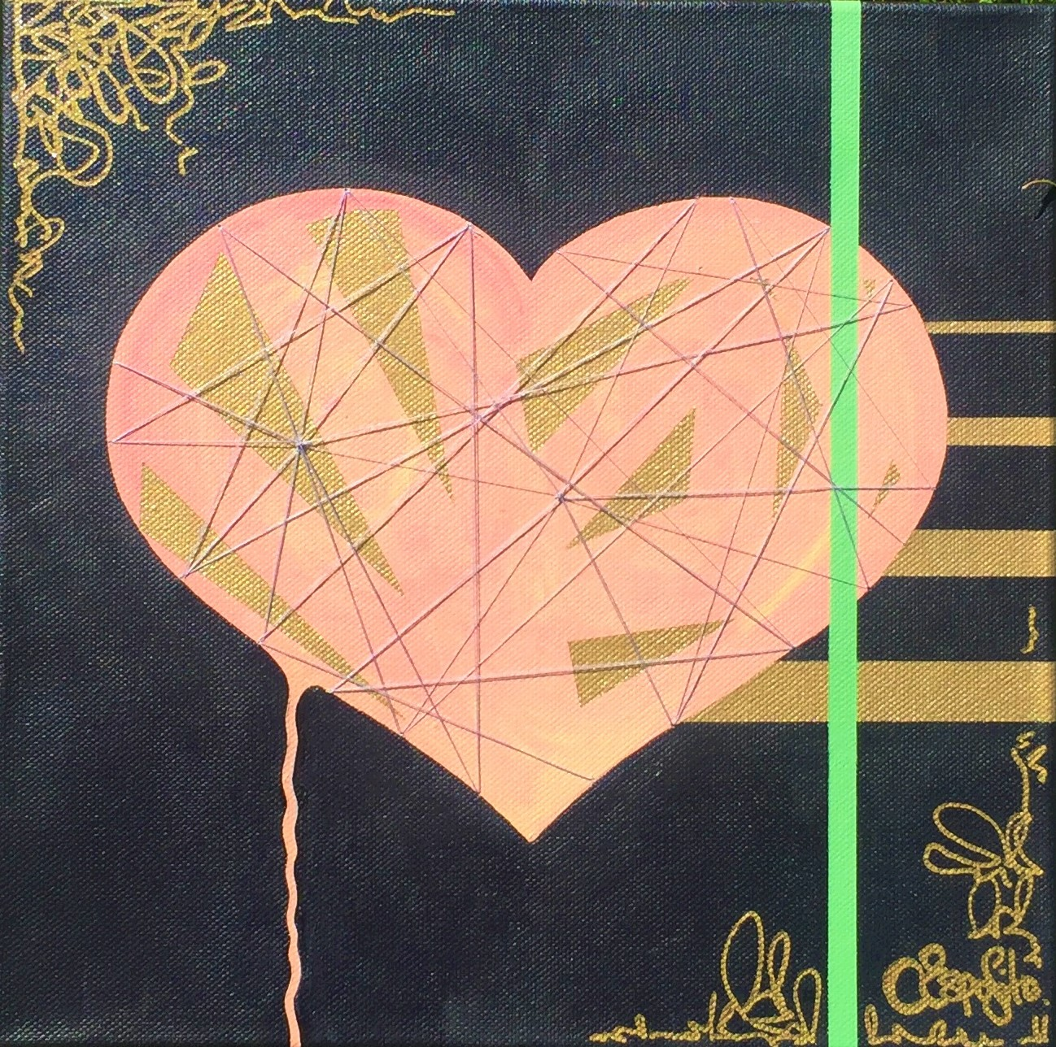

PRICE: £300 + shipping (if required)

Mixed Media on Canvas:
Acrylic, Silk Thread, Spray Paint, Gold Marker and Oil

Painting 4: Opulence, 2020
30 x 30 x 1.5 cm
Work in progress – to be finished shortly…

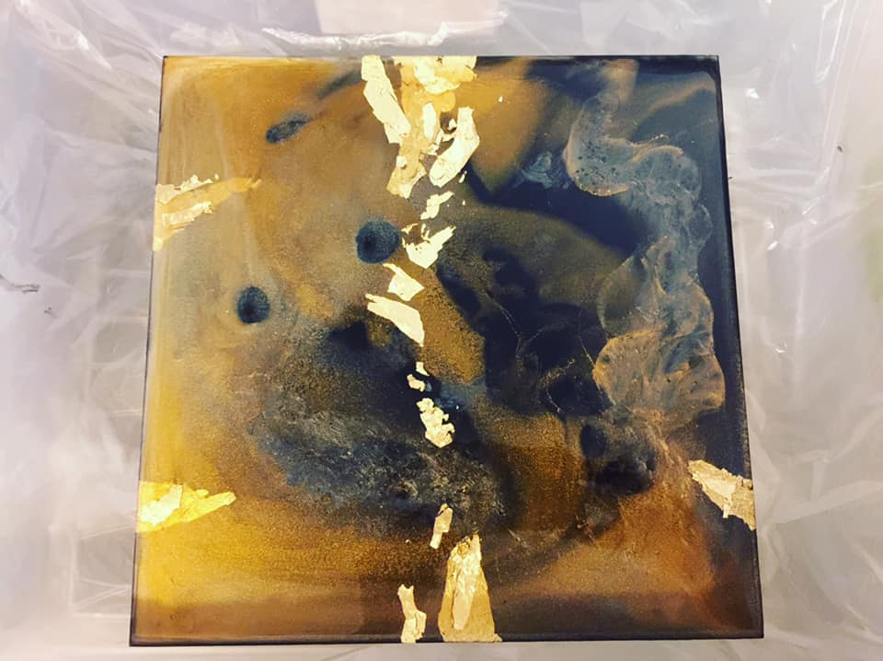

PRICE: £350 + shipping (if required)

Mixed Media on Canvas: Gold Leaf, Indian ink, Vitral & Resin

Painting 5: Velvet Circles, 2019
40 x 30 x 1.5 cm

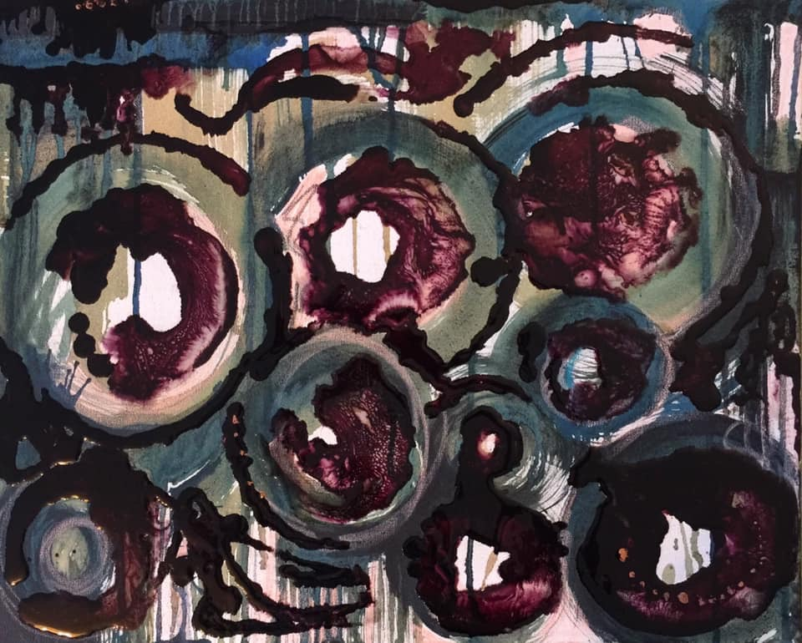

PRICE: £95 + shipping (if required)

Mixed Media on Canvas: Pastel, Indian ink, Coffee, Resin & Vitral

Painting 6: Soul Connection, 2019
100 x 120 x 4cm

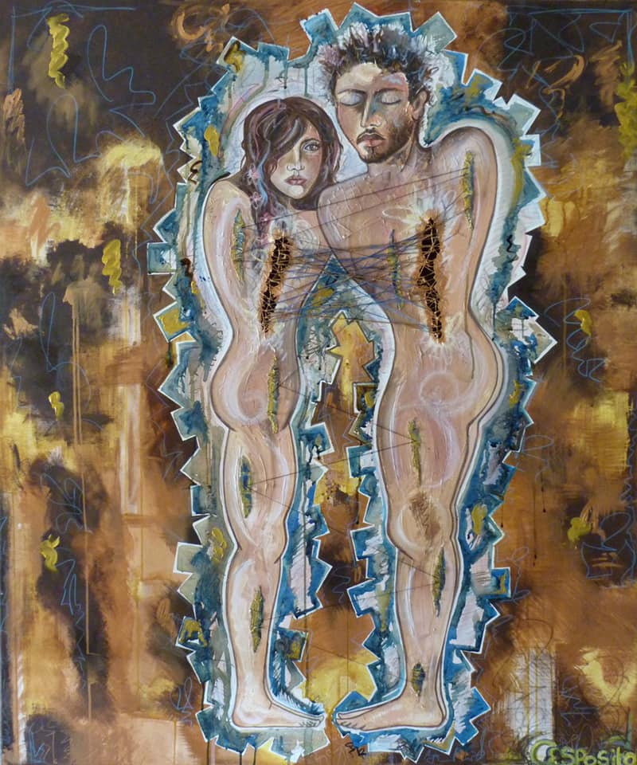

PRICE: £2200 + shipping (if required)
Mixed Media on Canvas: Oil, Acrylic, Indian ink, Coffee, Pastel, Pencil Crayon, Silk Thread, String & Gauze

Painting 7: The Butterfly, 2018
56 x 56 D x 0.1 cm

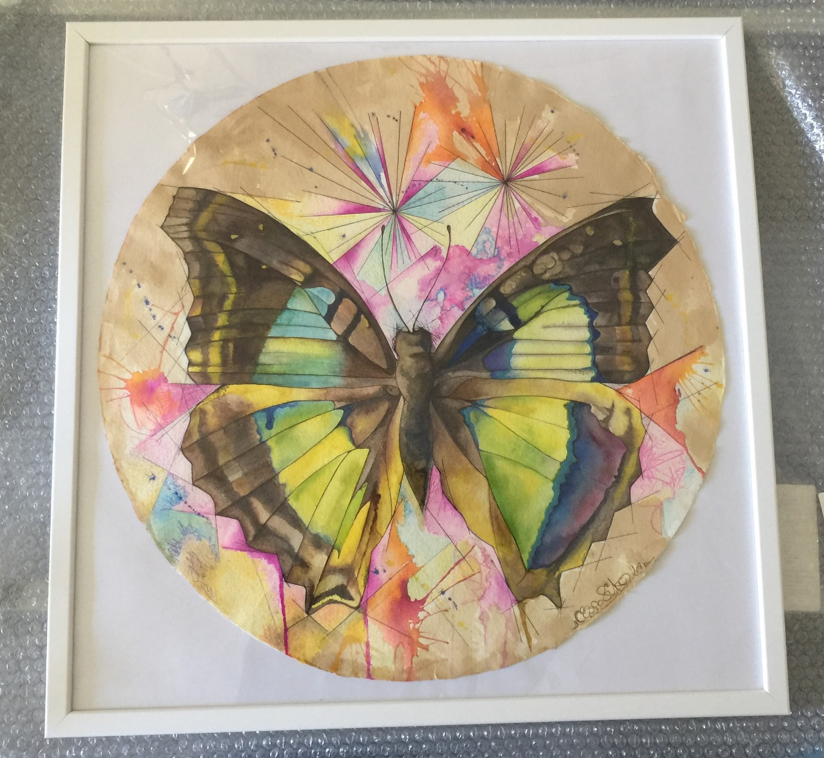

PRICE: £350 + shipping (if required)

Mixed Media on Art Paper: Watercolour, Biro, Pencil Crayon & Graphite on Japanese Art Paper (FRAMED)

Painting 8: Golden Decay, 2017
120 x 100 x 4 cm

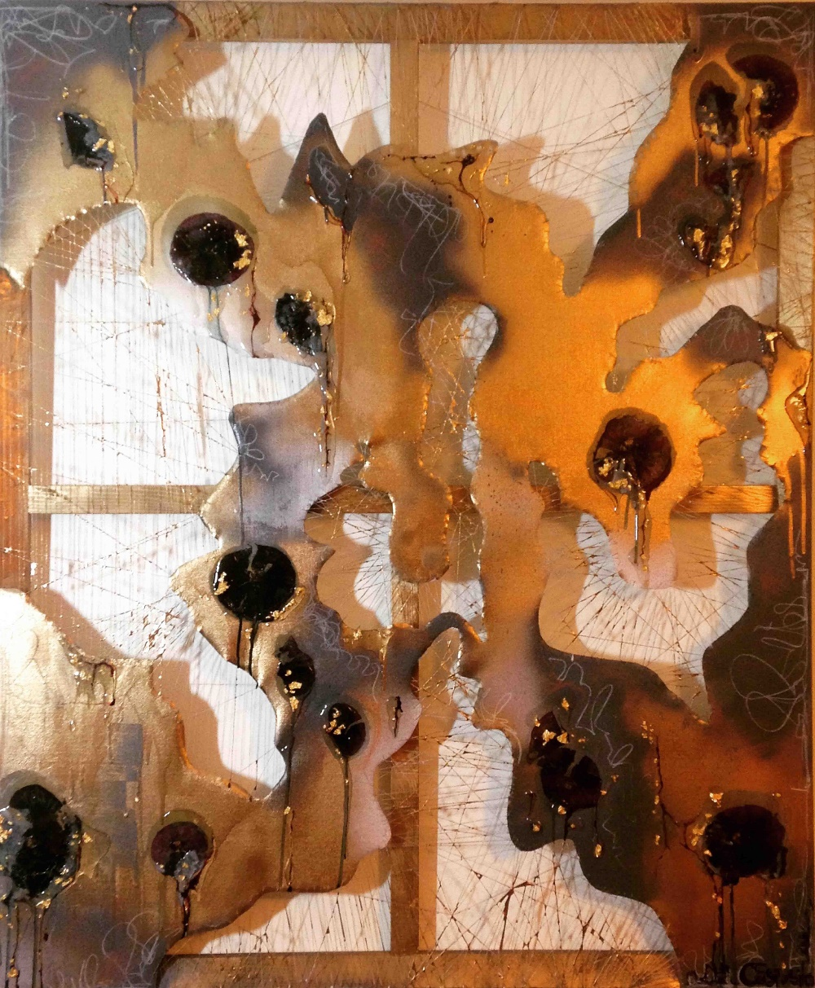

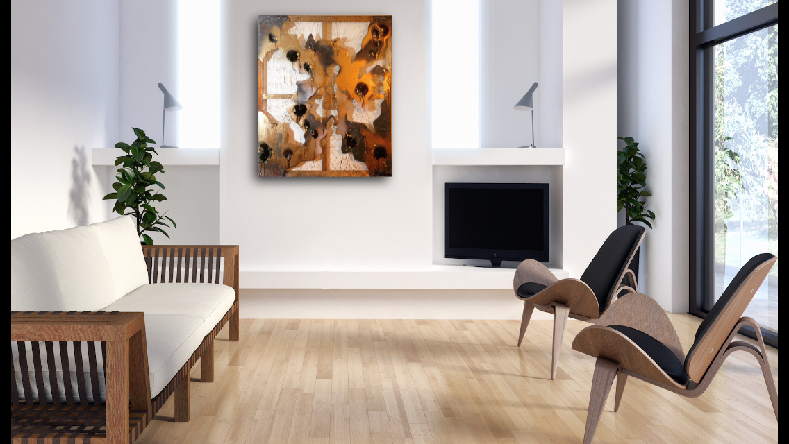

PRICE: £2000 + shipping (if required)

Mixed Media on Canvas: Spray Paint, Silk Thread, Resin, Pressed Flowers, Gold Leaf, Pastel & Graphite

Painting 9: The Burnt Lines, 2017
120 x 100 x 4 cm

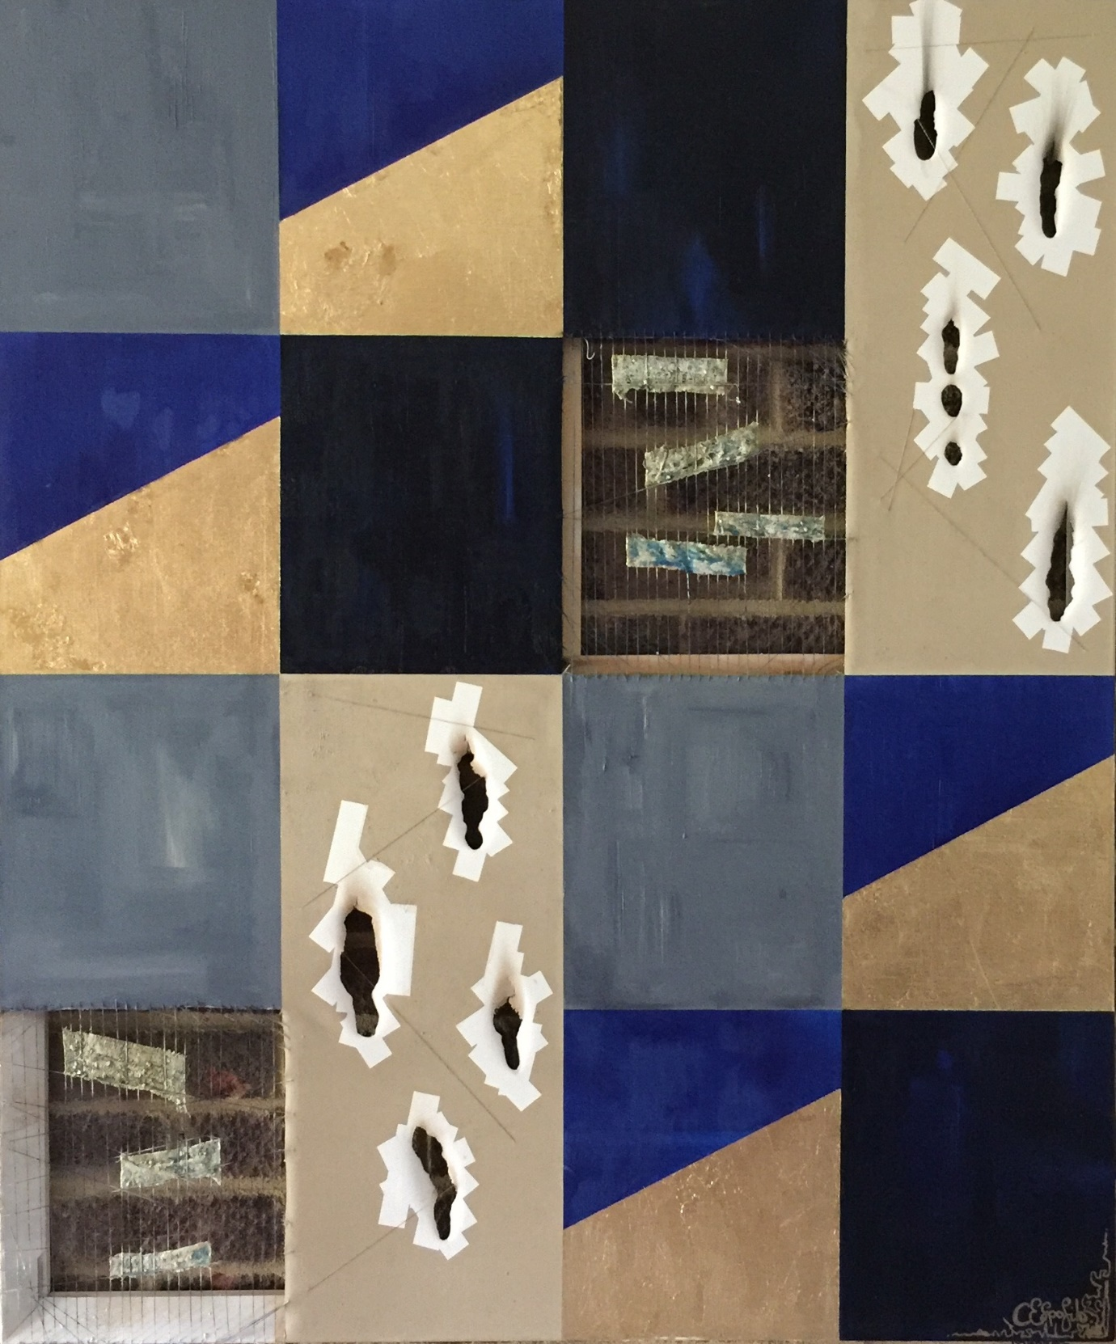

PRICE: £1950 + shipping (if required)

Mixed Media on Canvas: Oil, Gold Leaf, Indian ink, Resin, Silk Thread, Charcoal and Gauze

Painting 10: Path of Flight, 2016
100 x 100 x 4 cm
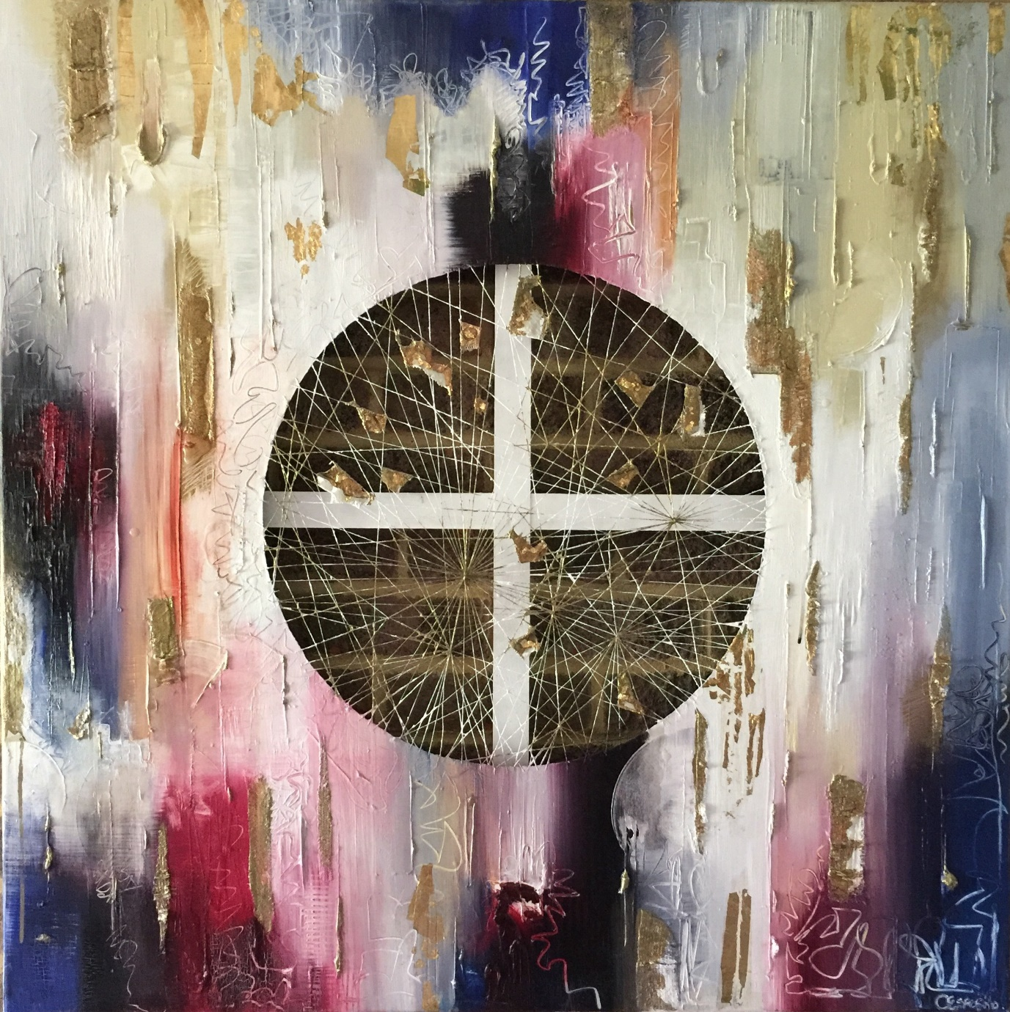

PRICE: £2000 + shipping (if required)
Mixed Media on Canvas: Oil (primary medium), acrylic, gold leaf, silk thread, resin, gauze & graphite

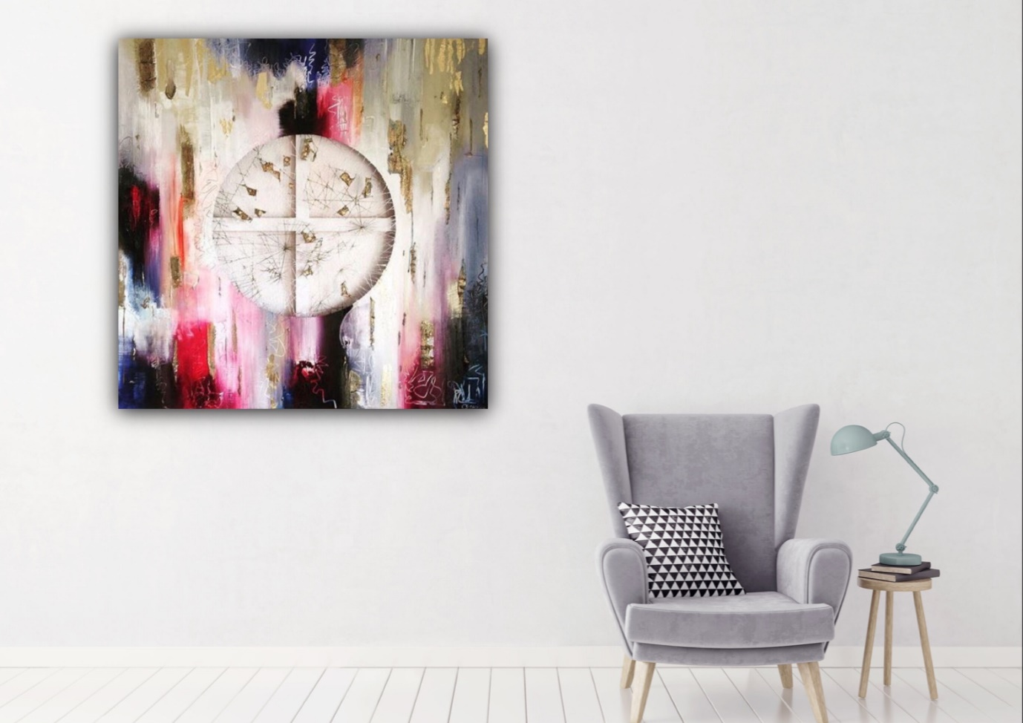

Painting 11: Technology SOS, 2016
40 x 50 x 4 cm

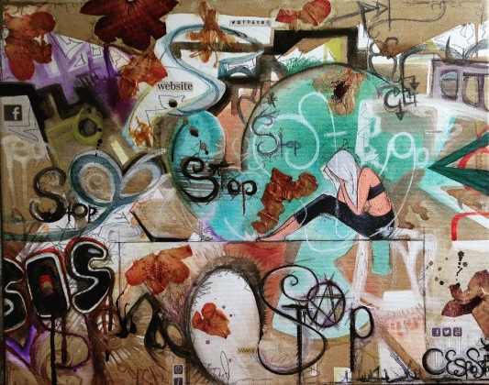

PRICE: £250 + shipping (if required)
Mixed Media on Canvas: Oil, Acrylic, Indian ink, Flowers, Magazine Cuttings, Coffee, Biro, Pencil Crayon and Graphite

Painting 12: Ghost, 2016
40 x 40 x 4 (cm)

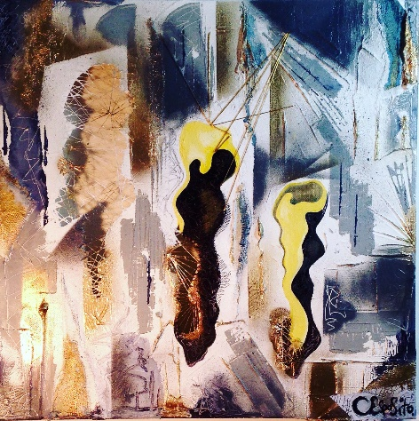

PRICE: £180 + shipping (if required)

Mixed Media on Canvas: Oil, Acrylic, Indian ink, Gauze, Silk Thread, Indian ink, Spray Paint and Pencil Crayon

Painting 13: The Wait, 2018
100 x 50 x 3 cm

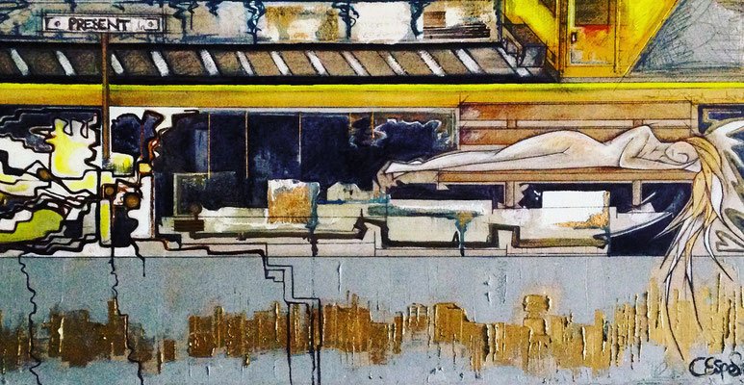

2018

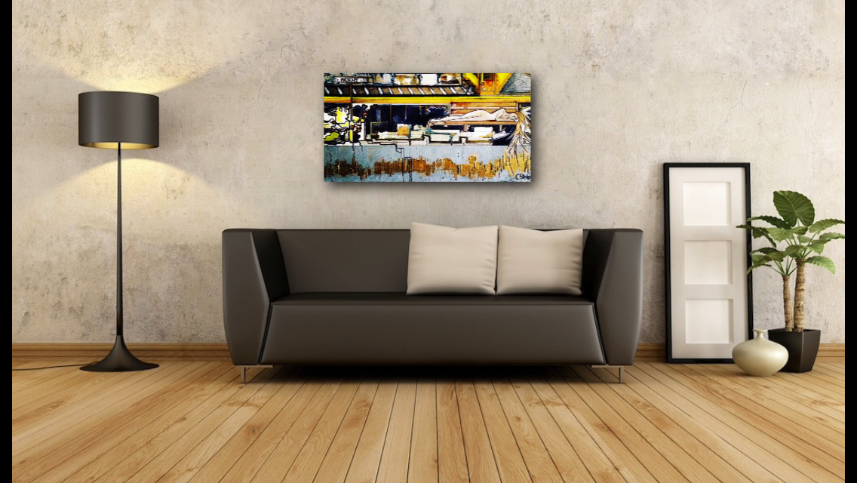

PRICE: £1350 + shipping (if required)

Mixed Media on Canvas: Oil, Acrylic, Indian ink, Coffee, Silk Thread, Pencil, Pastel, Biro, Pencil Crayon and Graphite on Linen Canvas

Painting 14: The Escape, 2015
40 x 40 x 3 cm

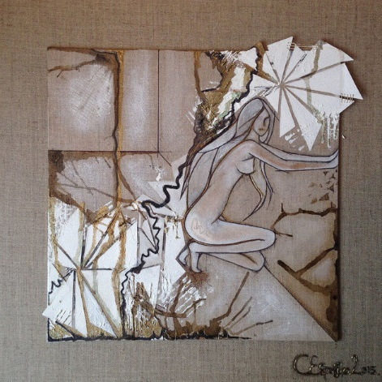

PRICE: £250

PRICE: £225 + shipping (if required)

Mixed Media on Canvas: Acrylic, Indian ink, Biro, Coffee, Whisky, Sand Paper, Gauze, Gold Thread and Pencil. Linen board mounted on Linen Canvas

Painting 15: Landscape of a Woman, 2015
x4 sections of 20 x 20 x 4 (cm)

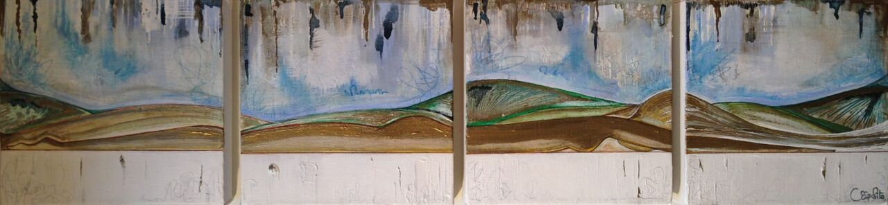

PRICE: £225 + shipping (if required)

Mixed Media Quadriptych on Cotton Canvas: Acrylic, Sculpture Paste, Indian ink, Pencil, Pencil Crayon and Graphite

Painting 16: In My Mind, 2015
100 x 120 x 1 cm

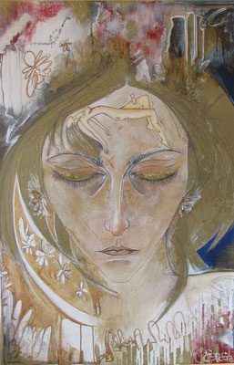

PRICE: £1150 + shipping (if required)
Mixed Media on Canvas:
Acrylic, Sculpture Paste, Indian ink, Coffee, Whisky, Gold Leaf, Biro, Pencil, Pastel and Graphite
Painting 17: Division, 2013
100 x 100 x 3 cm

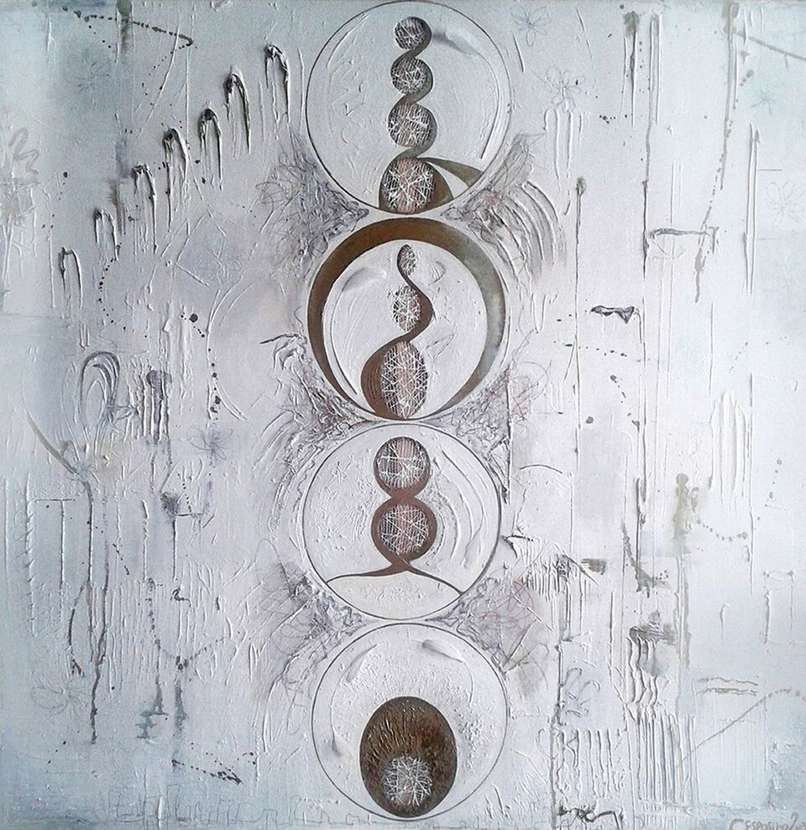

PRICE: £850 + shipping (if required)

Mixed Media on Canvas:
Sculpture Paste, Invisible Thread, Acrylic, Pastel, Pencil Crayon and Graphite

Painting 18: In Time, 2013
90 x 90 x 3 cm

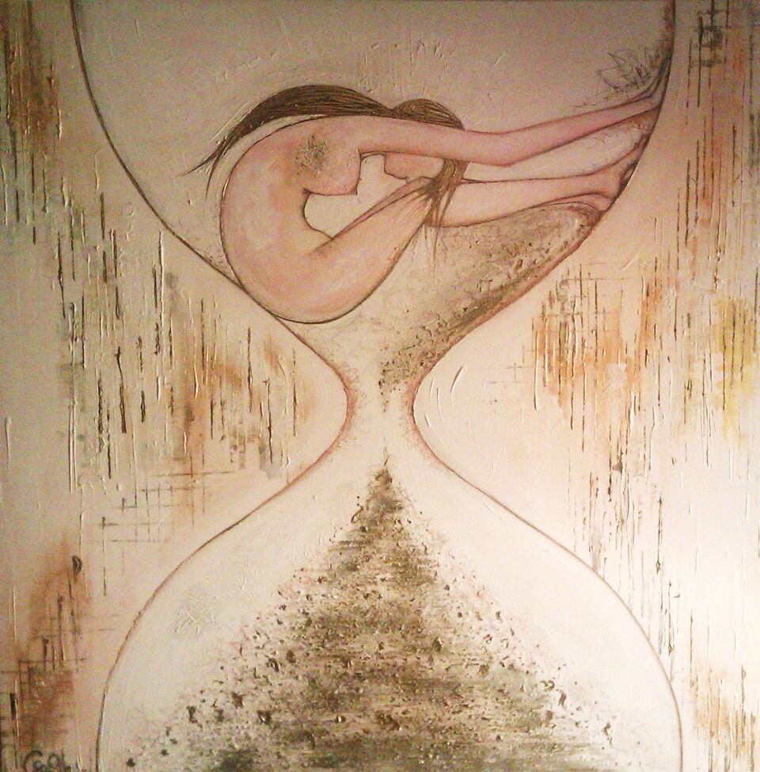

PRICE: £850 + shipping (if required)

Mixed Media on Canvas: Acrylic, Sculpture Paste, Sand, Gold Flecks, Indian ink, Pastel, Pencil, Pencil Crayon and Graphite

Painting 19: Lost Connection, 2013
60 x 120 x 3 cm

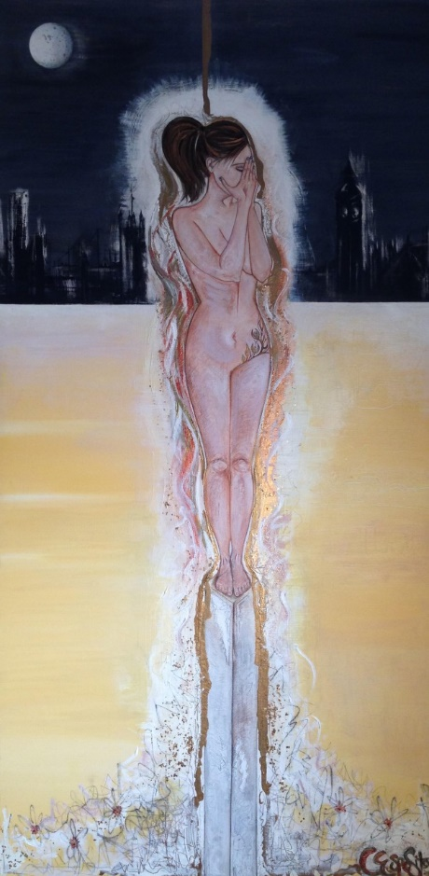

PRICE: £750 + shipping (if required)

Mixed Media on Canvas: Sculpture Paste, Acrylic, Indian ink, Pastel, Pencil Crayon, Biro, Graphite & Gold Flecks

Painting 20: The Offering, 2014

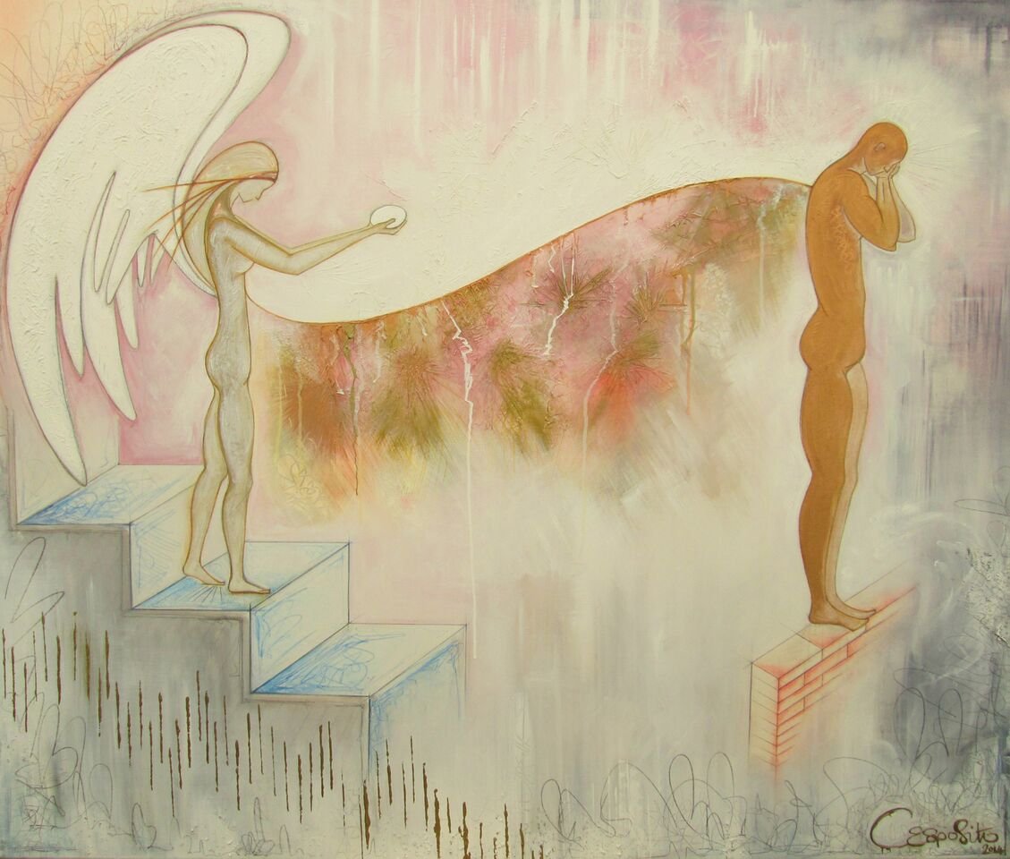

PRICE: £850 + shipping (if required)

Mixed Media on Canvas: Acrylic, Sculpture Paste, Pencil, Pastel, Indian ink, Pencil Crayon and Graphite

Painting 21: Assisted Conception, 2013
120 x 80 x 3 (cm)

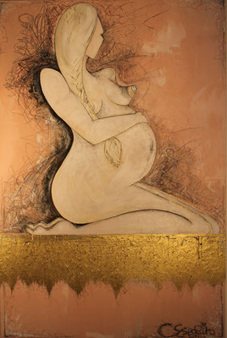

PRICE: £700 + shipping (if required)

Mixed Media on Canvas: Acrylic, Sculpture Paste, Pastel and Graphite

Painting 22: Womb, Head & Heart, 2012
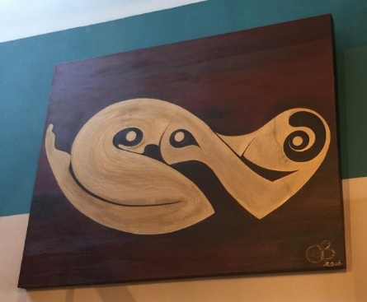

PRICE: £500 + shipping (if required)
Acrylic on Canvas

Tiny Art
Gold Dust
10 x 10 x 4cm

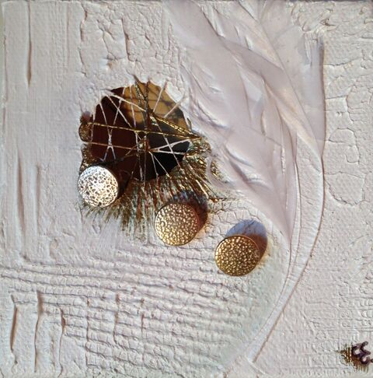

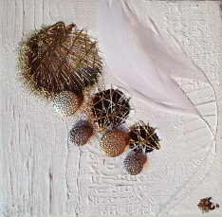

PRICE: £50 EACH or £100 for 2 + shipping (if required)
Mixed Media on Canvas: Acrylic, Silk Thread, Gold Buttons and Feather

Tiny Art
10 X 10 X 4 cm

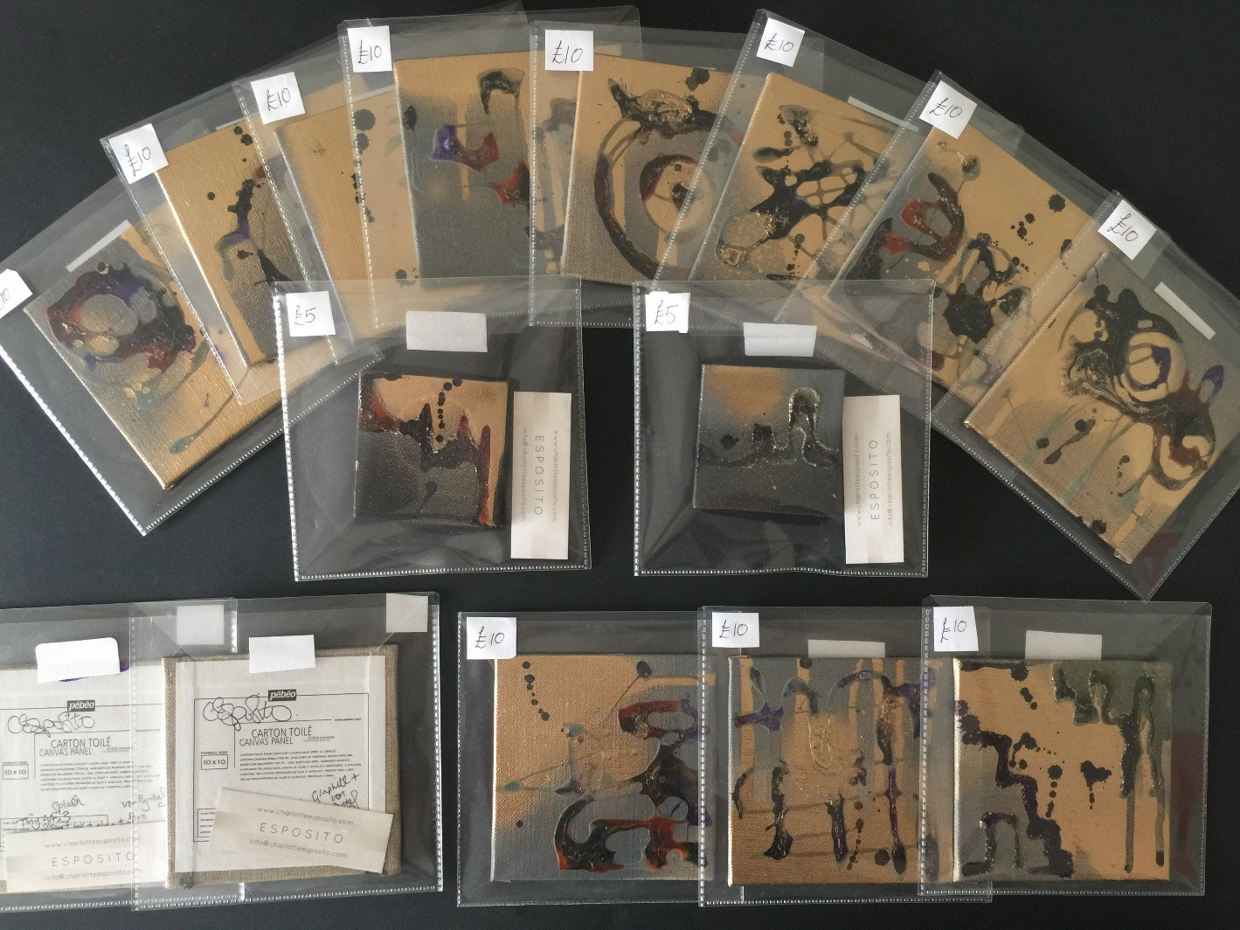
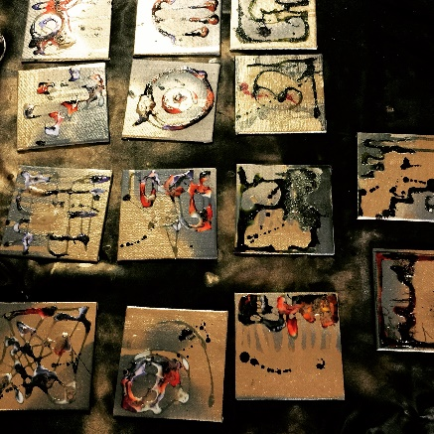
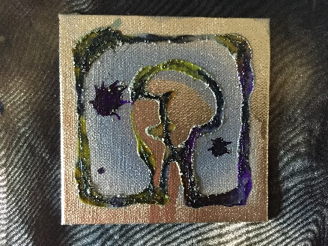

PRICE: £10 EACH – X6 LEFT + shipping (when required)
Mixed Media on Canvas: Acrylic, Spray Paint, Resin & Gold Rock

PREVIOUS PROJECTS & PICS OF COLLECTORS HOUSES, CORPORATE ART RENTAL (INTERIOR PHOTOGRAPHY), BUSINESS PREMISES & COMMISSIONS
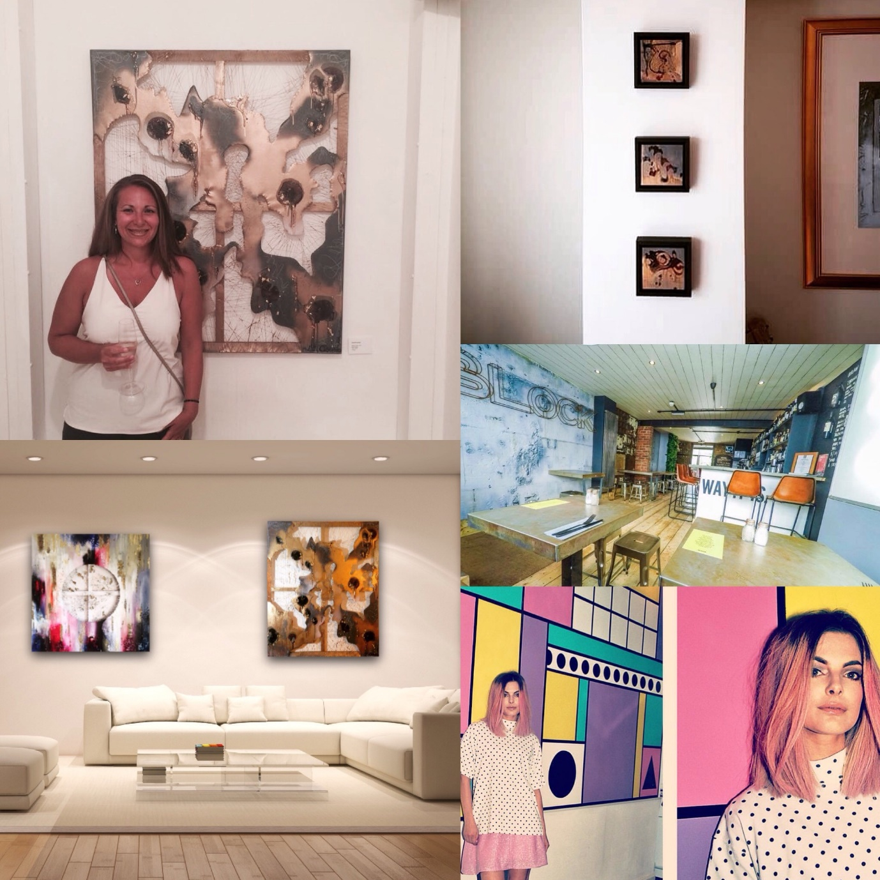

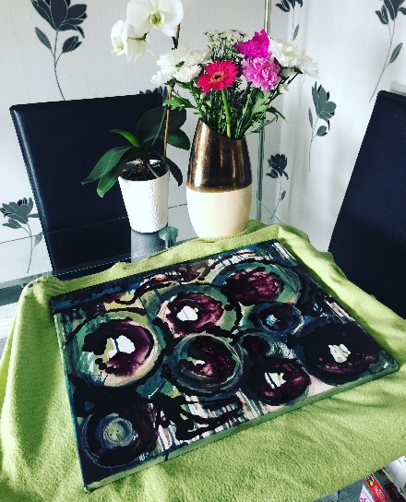
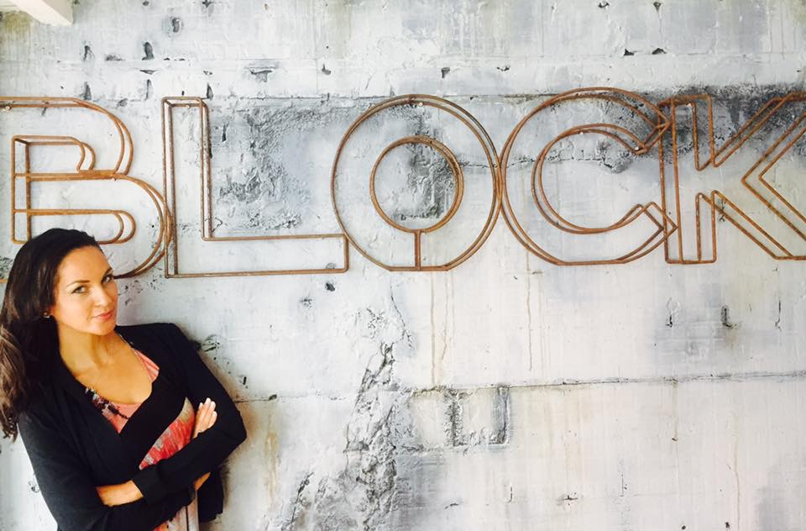

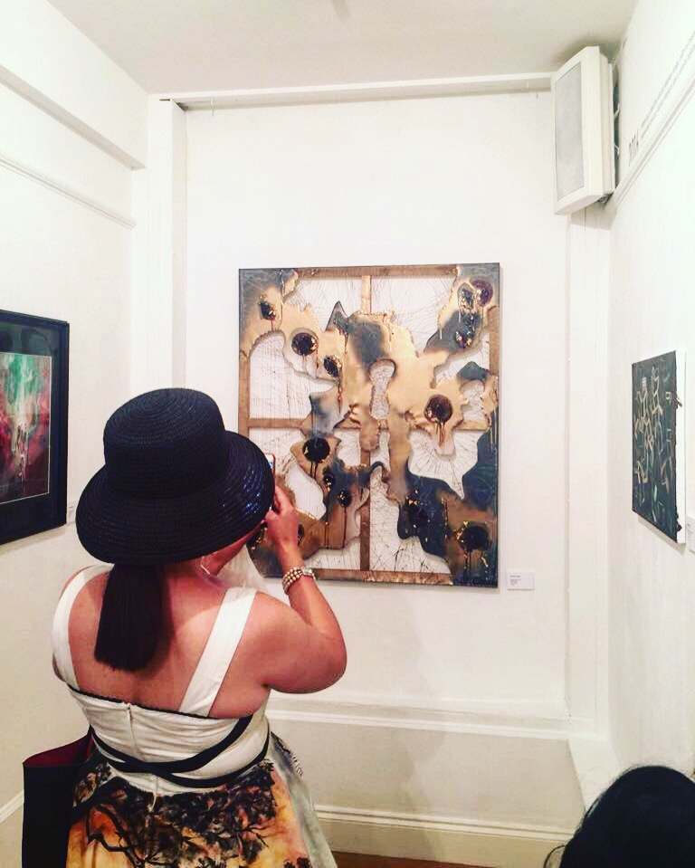
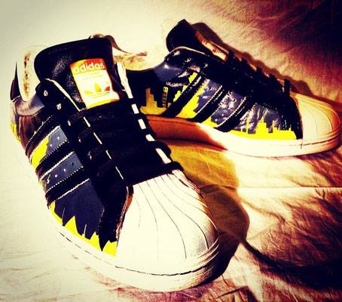

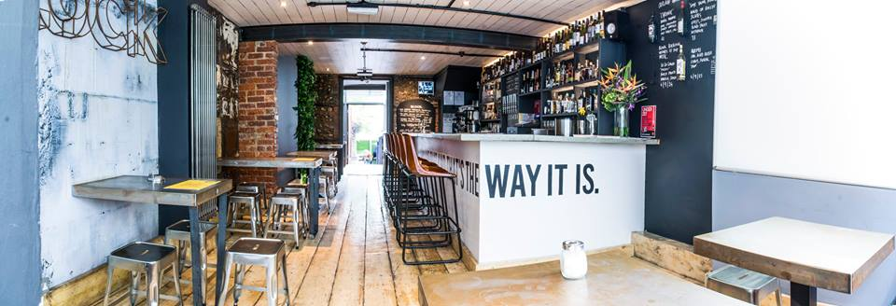
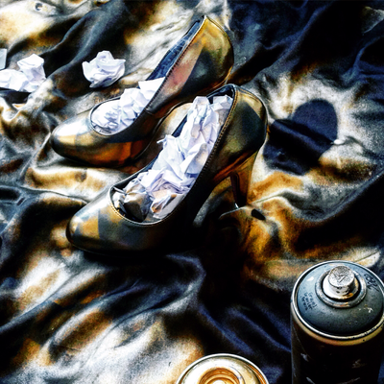
ART HABENS Magazine
“Multidisciplinary is a crucial feature of the work that reveals an incessant search of an organic, almost intimate symbiosis between traditional techniques and unconventional materials. Esposito’s hybrid approach is intrinsically connected to the chance of creating an area of intellectual interplay with the viewers, who are urged to evolve from the condition of a merely passive audience”.

Dario Rutigliano Curator & Editor.

